<https://medium.com/@SameerBramhecha/java-jumpstart-mastering-control-statements-1fafb5c4766b>

<https://www.linkedin.com/pulse/deep-dive-java-iteration-statements-enhancing-code-satish-jassal>

<https://www.geeksforgeeks.org/decision-making-javaif-else-switch-break-continue-jump/>

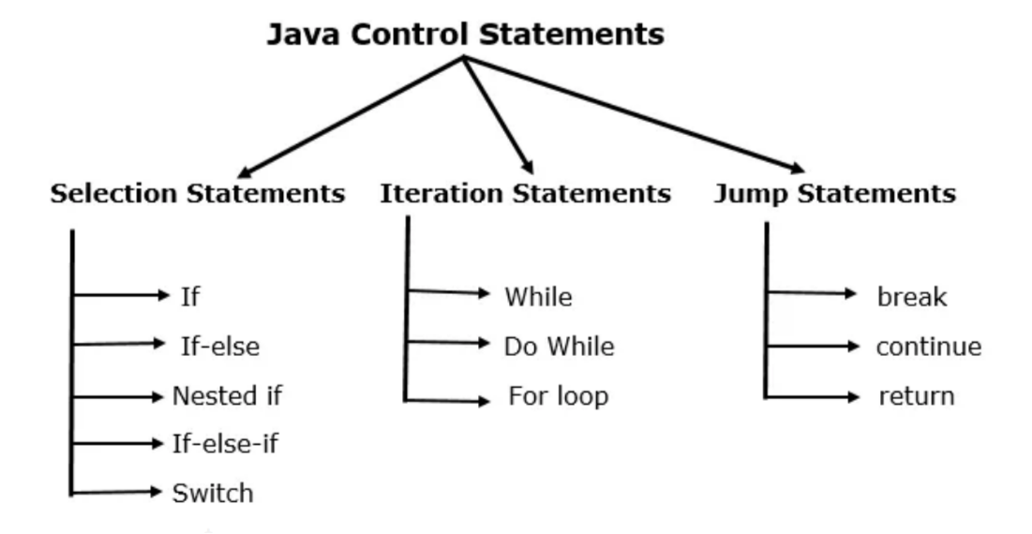

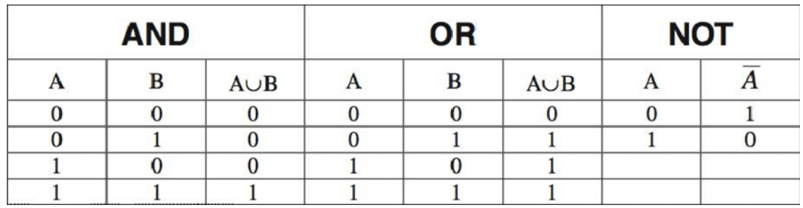

**AND --> && (double AND operator)** 🡪 If all conditions are true then only result will be true else result will be false.

**OR --> || (double pipes**)🡪 If any one conditions is true then only result will be true else result will be false.

We’ll explore three main types of control statements in Java:

**selection statements, iteration statements, and jump statements**. Selection statements allow your program to make decisions based on conditions. Iteration statements enable repetitive execution of a block of code until a condition is met. Jump statements provide more control over the flow of execution within loops and other control structures.

Java supports two selection statements: **if** and **switch.**These statements allow you to control the flow of your program’s execution based upon conditions known only during runtime.

**The ‘*if’*statement**

|  |
| --- |
| if(condition){  statement1; } else{  statement2; } |

**Nested ifs:**

An if statement inside another if statement.

|  |
| --- |
| /*  * This source file was generated by the Gradle 'init' task  */  package org.example;  public class App {  public static void main(String[] args) {  String userName = "kamal shaik";  String password = "abc123";  if (!userName.isEmpty() && !password.isEmpty()) { // ! ex cla mation --> NOT  System.out.println("Given value is not empty...");  if (userName.length() > 8 && userName.length() < 15) {  System.out.println("Strong password!");  } else {  System.out.println("Weak password!!!!");  System.out.println("Password length should be between 8 to 15 characters!");  }  } else {  System.out.println("The email address or mobile number you entered isn't connected to an account. Find your account and log in.");  }  }  } |

**If-else-if** ladder**:**

|  |
| --- |
| String name = "my name is Kamal"; if (name.isEmpty()) {  System.*out*.println("Name is empty!, Please enter you Name!!"); } else if (name.length() < 5) {  System.*out*.println("Name is lessthen 5 characters!!!"); } else if ((name.length() > 5 && name.length() < 10) || (name.length() > 10 && name.length() < 20)) {  System.*out*.println("Name is greaterthen 10 characters and lessthen 20 characters!!!");  System.*out*.println("Name is greaterthen 5 characters and lessthen 10 characters!!!"); } else {  System.*out*.println("I am DONE!"); } |

**Switch Statement:**

Instead of using many *if-else-if*statements, the *switch* statement will be used.

In case of if-else-if ladder all conditions will be checked line by line, if condition is true then only statements will be executed. If you have 100 if else if statements all 100 conditions are checked one by one. It is time consuming process, here unnecessarily we are checking all conditions.

To over come above issue they have introduced “SWITCH” statement. In case of switch statement, it will check for all the conditions, instead it will directly **jump to matching CASE**.

|  |
| --- |
| package com.skh; import java.io.FileReader;import java.util.Scanner;import java.util.concurrent.*;import java.util.stream.IntStream; public class App {  public static void main(String[] args) {  int inputValue = 2;  switch(inputValue){  case 1:  System.*out*.println("You choose Menu Option #1");  System.*out*.println("You choose Menu Option #1");  System.*out*.println("You choose Menu Option #1");  System.*out*.println("You choose Menu Option #1");  System.*out*.println("You choose Menu Option #1");  System.*out*.println("You choose Menu Option #1");  break;  case 2:  System.*out*.println("You choose Menu Option #2");  break;  case 3:  System.*out*.println("You choose Menu Option #3");  break;  default:  System.*out*.println("You choose an unavailable option");  }  System.*out*.println("End of the program..!!!");  } } |

|  |
| --- |
| String name = "Azad"; switch (name){  case "Kamal" :  System.*out*.println("Hi this is " + name);  break;  case "Arafath":  System.*out*.println("Hi this is " + name);  break;  case "Azad":  System.*out*.println("Hi this is " + name);  break;  default:  System.*out*.println("Invalid name entered!"); } |

**Java Iteration Statement:**

Iteration Statements, or what we generally call as loops, allow us to execute a block of code repeatedly as long as a condition is met/satisfy. There are three main types of loops in Java: ***‘while’, ‘do-while’ and ‘for’***loop.

***for* Loop:**

|  |
| --- |
| *for (int index = 10; index <= 40 ; index++){*  */*  1.* ***initialization*** *it is starting position.  2.* ***condition*** *--> till what level loop should iterate.  3.* ***increment or decrement*** *\*/* System.*out*.println(index);  } |

***For loop Execution flow:*** *1. intialization + condition checking = true --> go inside loop execute statements.*

*This part runs only once at the beginning of the loop.  
 2.It will go to increment / decrement section. + it will check for condition.  
 if condition is true it will execute inside statements.  
 3.It will go to increment / decrement section. + it will check for condition.  
 if condition is true it will execute inside statements.  
 4. when ever condition fails it will exit from loop.*

**Infinite loop:**

If we don’t keep initialization section and condition section and increment or decrement section properly, it may fall under infinite loop.

In infinite loop it will always execute inside loop only, it will not come out of loop. In this case as loop running continuously it will occupy your system RAM and system will get hang.

|  |
| --- |
| **for (; ; ) { *// infinite loop***System.*out*.println("Hi Azad...!"); }  **for (int i = 0; ; i++) { *// infinite loop***System.*out*.println("Hi Azad...!"); } |

We need to create while creating loops.

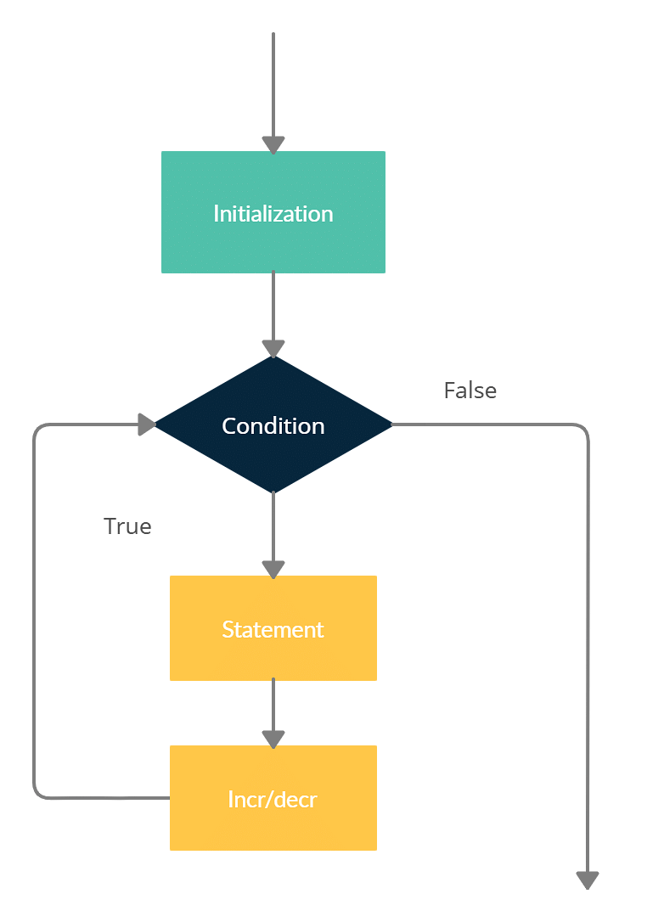

<https://www.programiz.com/java-programming/for-loop>

**Stars Program:**

|  |
| --- |
| for (int x = 1; x <= 7; x++) {  for (int y = 1; y <= x; y++) {  System.out.print("* ");  }  System.out.println();  } |

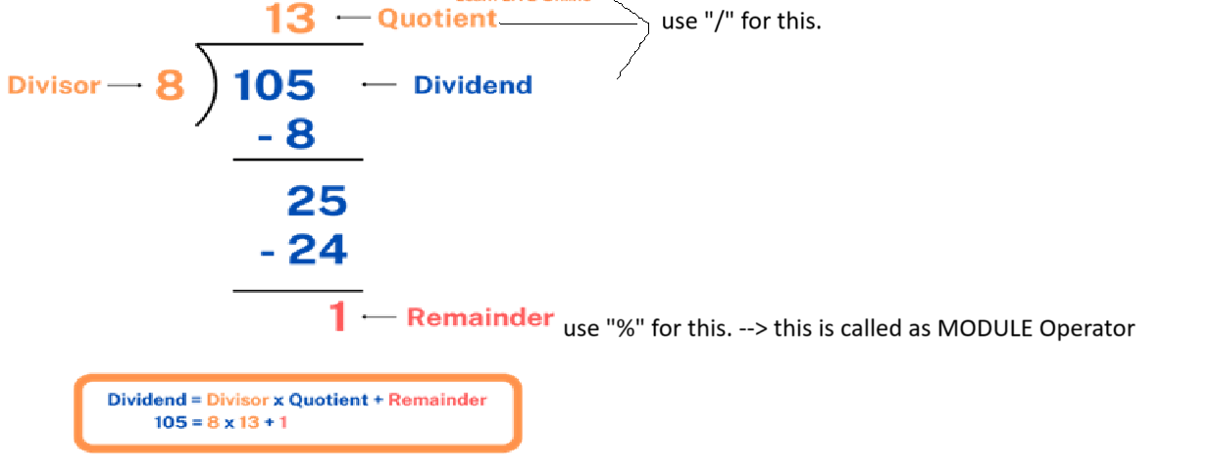

**Program: PRIME numbers program.**

[Java Program to Check Whether a Number is Prime or Not](https://www.programiz.com/java-programming/examples/prime-number)

**While loop:**

Syntax:

|  |
| --- |
| while (condition){  // body of the loop } |

Example:

|  |  |
| --- | --- |
| int i = 0; *// variable declaration / initialization.* while (i < 10) { *// condition checking* System.*out*.print(i + " ");  i++; *// increment / decrement* } | For loop:  for(int i = 0; i < 10; i++){  System.*out*.print(i + " ");  } |

While loop also we write like for loop only, but syntax representation changes.

**“While” means అయితే.**

If condition is true it ill go inside the loop, then increment happens, then again it checks the condition again it will go inside loop, until condition fails this loop repeats.

String[] strArr = {"Azad", "Arafath", "Kamal**"};*// Collection Similar data = Array.***

In Array every value has one index value. INDEX values always starts from “0”,1,2,3,4,5…etc incremental manner.

Why INDEX?

If you want to iterate or fetch values from an array we need to make use of INDEX’s only.

IndexValue = arrayValue -1; 🡪 N-1.

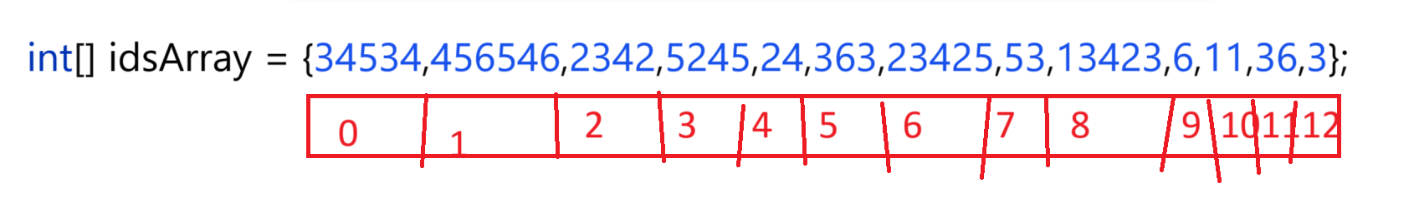

|  |
| --- |
| int**[]** idsArray = {1111,456546,2342,3433,4444,5555,66666,777774,2232,45664,53,13423,6,11,36,3,23,34,12,4};  System.*out*.println("Array Length : "+idsArray.length);  **for (int i = 0; i < idsArray.length; i++) {  System.*out*.println(idsArray[i]); }** |

|  |
| --- |
| int**[]** idsArray = {1111, 456546, 2342, 3433, 4444, 5555, 66666, 777774, 2232, 45664,  5245, 24, 363, 23425, 53, 13423, 6, 11, 36, 3, 23, 34, 12, 4};  System.*out*.println("Array Length : " + idsArray.length);  **int i = 0; while (i < idsArray.length) {  System.*out*.println(idsArray[i]);  i++; }** |

